

GREEN UNIVERSITY OF BANGLADESH
Department of Computer Science and Engineering (CSE)
Faculty of Sciences and Engineering Semester: (Fall 2025), B.Sc. in CSE (Day)

Lab Report #2
Course Title: Microprocessors and microcontrollers

Course Code: CSE 304 Section: 232_D4

Lab Experiment Name: Find out the largest number between two numbers using assembly language.
Printing Two Characters in Reverse Alphabetical Order Using 8086 Assembly Language.

Student Details

Name |  | ID
1. | Meherin Afrin Muna | 232002149

Submission Date : 29-10-2025
Course Teacher’s Name : Jarin Tasnim Tonvi

[For Teachers use only: Don’t Write Anything inside this box]
Project Report Status
Marks: ………………………………… Signature:..................... Comments:.............................................. Date:..............................
- TITLE OF THE LAB REPORT EXPERIMENT:

Find out the largest number between two numbers using assembly language.

- OBJECTIVES/AIM:
- To take two single-digit inputs from the keyboard using the DOS interrupt (INT 21H).
- To compare the two input values using the CMP and JGE instructions.
- To store and display the larger of the two numbers as the final result.
- To understand the process of input and output handling in assembly language through DOS interrupts.
- To develop and practice decision-making logic in assembly language programming.

3. IMPLEMENTATION PLAN & SYSTEM DEVELOPMENT :
- Setup: Initialized the data segment to properly define and use variables.
- Input: Accepted two numeric inputs from the user and converted them from ASCII characters to their corresponding numerical values.
- Comparison: Used the CMP and JGE instructions to compare the two numbers and determine the larger value.
- Output: Displayed the greater number on the screen along with an appropriate message.
- End: Gracefully terminated the program using INT 21H.
- IMPLEMENTATION:
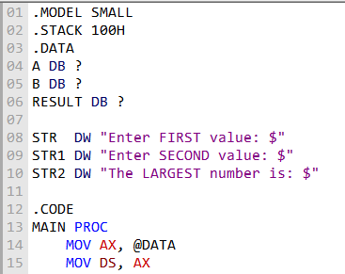

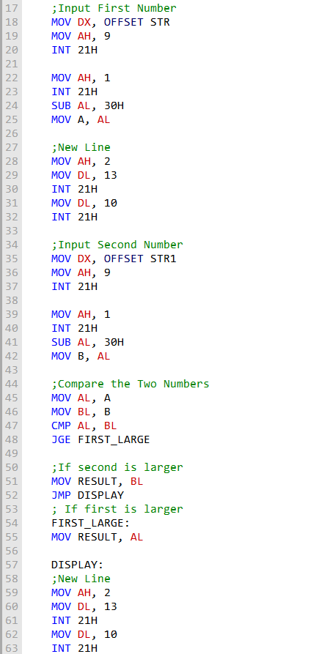
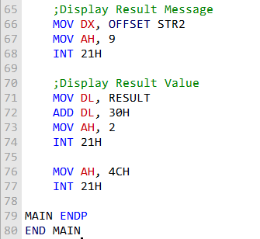
- OUTPUT:
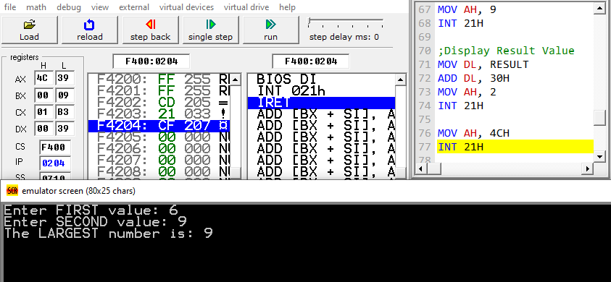

- ANALYSIS AND DISCUSSION:
In this program, the process of comparing two numbers using assembly language was examined. The implementation of the CMP and JGE instructions effectively determined which number was greater. Performing input and output operations through DOS interrupts enhanced my understanding of data handling in the 8086 microprocessor. By testing the program with various inputs, it was confirmed that the logic worked accurately in all scenarios. Overall, this experiment deepened my understanding of conditional logic, program control flow, and assembly-level data processing.
- SUMMARY :
Through this program, I learned how to take user input, compare two values, and display the larger number using 8086 assembly language. The task provided hands-on experience with conditional branching, data storage, and DOS interrupt routines. Implementing and testing the program helped me clearly understand the sequential flow of an assembly language program. In summary, this exercise significantly improved my skills in decision-making logic and the fundamentals of assembly programming.

- TITLE OF THE LAB REPORT EXPERIMENT:

Printing Two Characters in Reverse Alphabetical Order Using 8086 Assembly Language.

- OBJECTIVES/AIM:
- The aim of this program is to take two characters as input from the user and display them in reverse alphabetical order.
- I wrote this program to understand how to use comparison (CMP) and conditional jumps (JG) in assembly language.
- It also helps practice input/output operations using DOS interrupts and basic assembly logic.

- IMPLEMENTATION PLAN & SYSTEM DEVELOPMENT :
- Set up the data segment to enable access to program variables.
- Read two characters from the keyboard using DOS interrupt routines.
- Used CMP to compare the characters and JG (jump if greater) to decide their order.
- Printed the characters in reverse alphabetical order.
- Ended the program properly using INT 21H.
- IMPLEMENTATION:
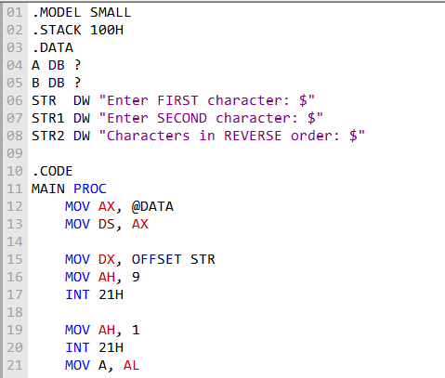

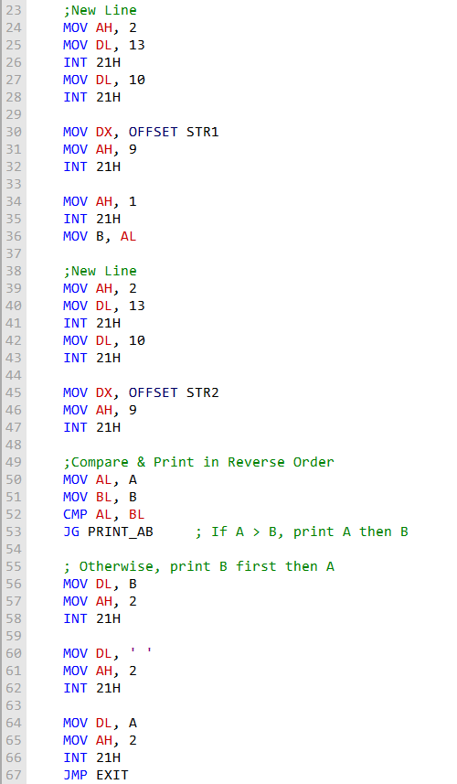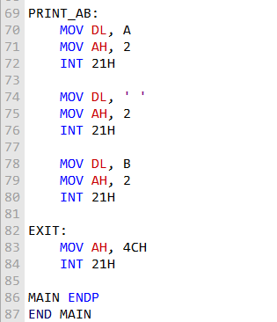
- OUTPUT:
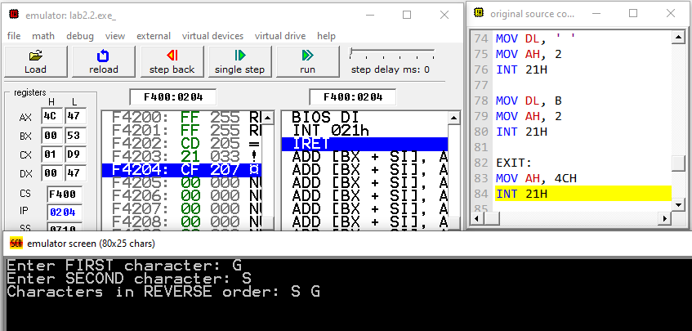

- ANALYSIS AND DISCUSSION:
This program demonstrates how characters can be compared and arranged using assembly language instructions. The implementation of CMP and JG enables the program to determine which character appears first alphabetically. Input and output operations performed through DOS interrupts enhanced my understanding of user interaction in assembly. Testing with various character inputs confirmed that the program functions correctly under all conditions. Overall, this experiment improved my grasp of conditional logic, character comparison, and program control flow in 8086 assembly programming

- SUMMARY :
In this program, I learned how to take user input, compare two characters, and display them in reverse alphabetical order using 8086 assembly language. The exercise provided valuable practice in conditional branching, character manipulation, and DOS interrupt operations. Through implementation and testing, I gained a clearer understanding of the logical structure and execution flow of assembly language programs.

